**Lab Submission Worksheet**

**Laboratory 4 — Sp02**

Lab Group: Date: November 11th, 2019

Student 1 Student 2

Name: Adam Rocco Name: Josh Hayles

Student Number: 101025114 Student Number: 101031998

Instructions

**Step 1**

Complete the Lab and take screenshots requested. They will be used to answer the questions.

**Step 2**

Write your answer to all questions in the provided boxes.

**Step 3**

Submit to the drop box for “sysc4203” outside ME4460 before 2:00pm one week after the lab.

**Report**

**a)** **Plot your unprocessed and processed Pulse Rate data for one ‘testing’ file.**

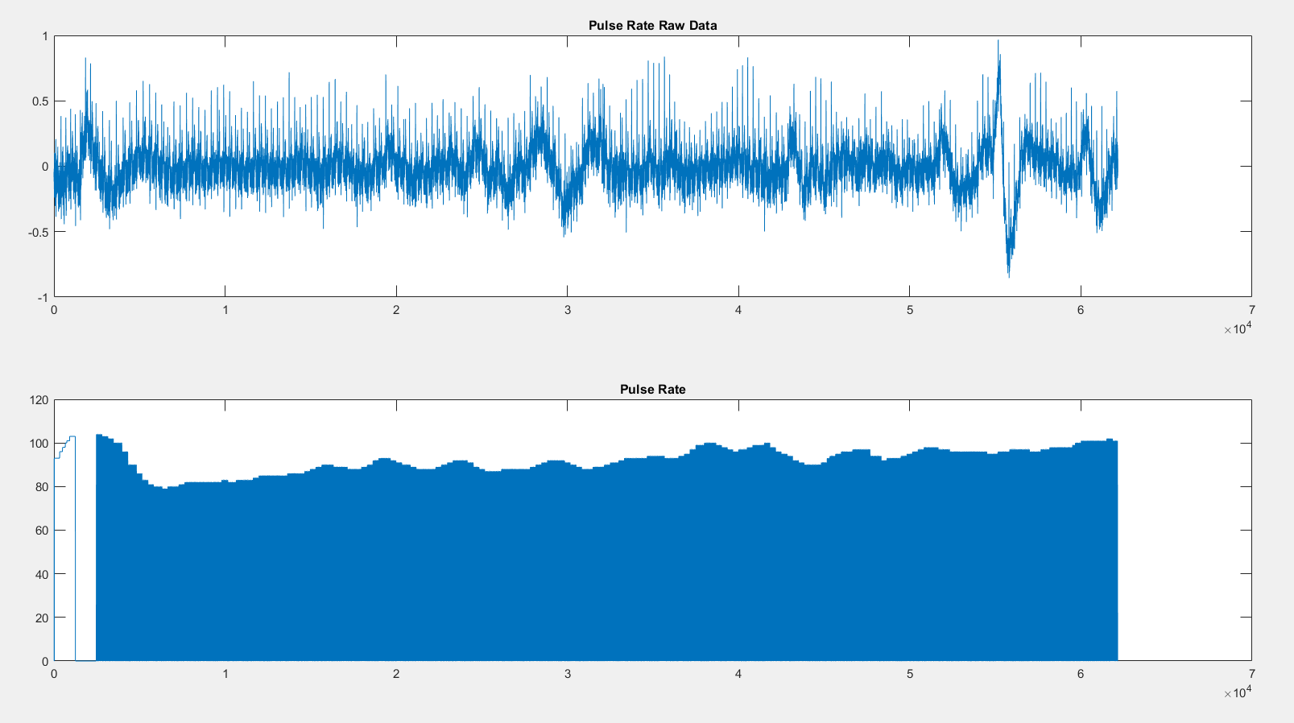

Figure 1. Unprocessed Pulse Rate

**i) What is the mean Pulse Rate for the entire Pulse Rate channel for the unprocessed and processed data? Is the second value realistic? (Hint: should be close to your HR).**

The mean pulse rate for the processed data was 88.3902 BPM. The mean pulse rate for the unprocessed data was 44.0715 BPM. The reason the second value is so low and unrealistic is because the signal was recorded as a square wave so the mean value sits at about half of the enveloped values.

**ii) Paste your Matlab code HERE.**

a = load('Subject1_test.data');

figure(1);

ax(1) = subplot(4,1,1);

plot(a(:,1));

title('Respiratory Effort');

ax(2) =subplot(4,1,2);

plot (a(:,2));

title('ECG');

ax(3) = subplot(4,1,3);

plot(a(:,3));

title('SpO2');

ax(4) = subplot(4,1,4);

plot(a(:,4));

title ('Pulse Rate');

linkaxes(ax,'x');

figure(2);

[YUPPER1,YLOWER] = envelope (a(:,3), 1,'peak');

[YUPPER2,YLOWER] = envelope (a(:,4), 1,'peak');

bx(1) = subplot(2,1,1);

plot(YUPPER1);

title ('SpO2 Envelope');

bx(2) = subplot(2,1,2);

plot (YUPPER2);

title ('Pulse Rate Envelope');

linkaxes (bx, 'x');

sumdata1 = sum(YUPPER2,[1:65000]);

avgenv = sumdata1 / 65000

sumdata2 = sum(a(:,4),[1:65000]);

avgraw = sumdata2 / 65000

**b)** **‘Testing’ file: For 1 subject, plot your data in the following format (adding appropriate tiles & axis labels), and indicate on the breathing plot where the type of breathing changes.**

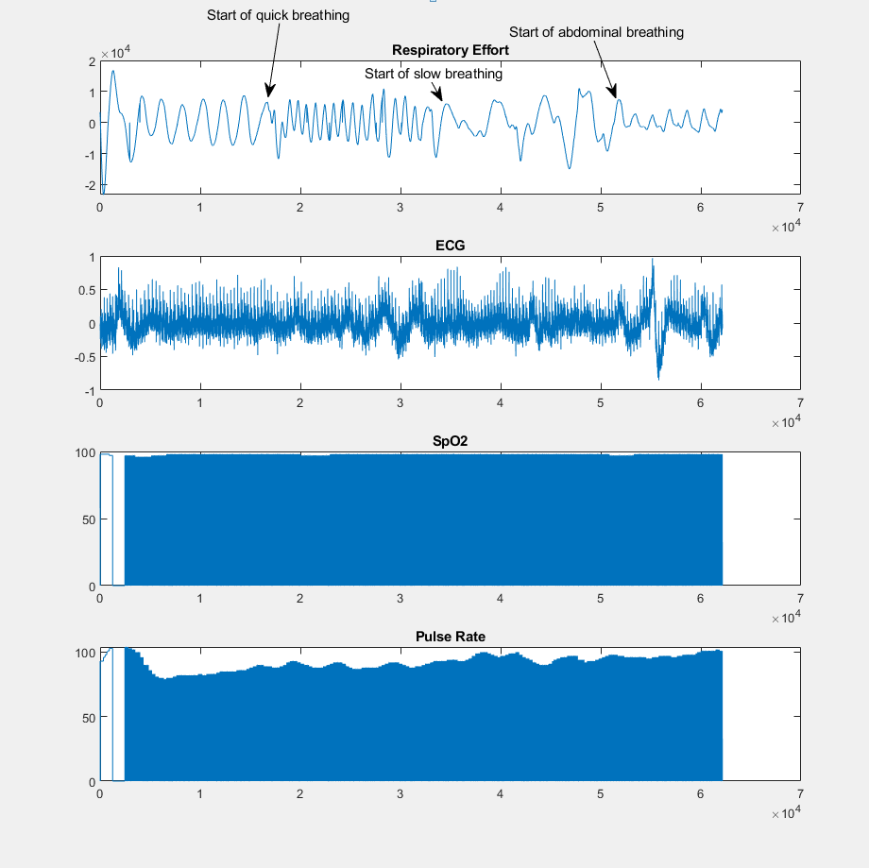

Figure 2. Testing Plot

**c) ‘Testing’ files: For each type of breathing (Br.) (regular, fast, slow and abdomen) find:**

Table 1. Measured parameters for each breathing technique

| Breathing Type | Breathing Amplitude | Breathing Rate  (Breaths per min) | Sp02 | Pulse |
| --- | --- | --- | --- | --- |
| Regular Breathing | 8854 | 14 | 97.4 | 88.7 |
| Fast Breathing | 6896 | 26 | 97.8 | 89.6 |
| Slow Breathing | 6645 | 12 | 98.0 | 94.0 |
| Abdomen Breathing | 4766 | 12 | 97.8 | 96.0 |

**Comparing the Reg. Br. to the Fast Br., what was the effect of hyperventilation on Sp02? Pulse? What was the increase/reduction (in %) of the resp. signal amplitude?**

Hyperventilation slightly increased avg Sp02 and Pulse rate as the extrapolated values for fast breathing where marginally higher than that of regular breath. The amplitude of the respiratory effort signal during fast breathing was 23% less than the amplitude during normal breathing was reduced by a factor of 23%.

**i) Knowing the sampling rate of the resp. sensor, how fast would you have to breathe to avoid detection? Show your calculations and specify units.**

The sampling rate of the signal is 500 samples per sec thus every sample takes approximately 2ms. Thus you would have to breathe faster than 4ms between breaths to avoid detection.

**ii) Comparing Reg. Br. to Slow Br., what was the effect of hypoventilation on Sp02?**

**Pulse? What was the increase/reduction (in %) of the resp. signal amplitude?**

The avg Sp02 and avg Pulse where slightly higher for Slow breathing than for Regular breathing. There was a reduction in respiratory signal amplitude by a factor of 25%.

**iii) Comparing Reg. Br. to Abdomen Br., was a breathing signal detected? If so what was the reduction (in %) of the resp. signal when breathing with the abdomen?**

Breathing was detected but only very faintly , there was a reduction of the respiratory signal amplitude by a factor of 46% when comparing the amplitudes of the regular breathing respiratory signal and the Abdomen breathing signal.

**iv) Discuss the relationship between breathing, Sp02 and pulse rate (does pulse rate increase/decrease with SpO2). Explain why it’s a good thing that the relationships work this way (~200 words).**

The relationship between Sp02 and breathing with pulse rate is that pulse rate and Sp02 are inversely proportional so if Sp02 is low, pulse rate will increase to compensate for the lack of oxygen in the tissues around the body. The higher the pulse rate the more blood that is carrying oxygen around the body, thus increasing Sp02. Breathing ties in directly with Sp02, by breathing faster Sp02 will begin to raise because the body has an excess amount of oxygen to exchange within the lungs, more oxygen means more to be carried through the body, pulse rate doesn't necessarily have to change with the other two measurands. This is a good relationship because it allows the body to naturally remain at equilibrium. If your body needs more oxygen in its tissues, you will begin breathing faster and your heart rate could naturally increase to compensate for the need. It also aids doctors in diagnosing problems, for example just by watching a patients breathing the doctor will be able tell generally what their heart rate and Sp02 is about.

**d)** ‘**Hold_Inhale’ files. Plot the resp. signal and indicate where breath hold starts and ends**.

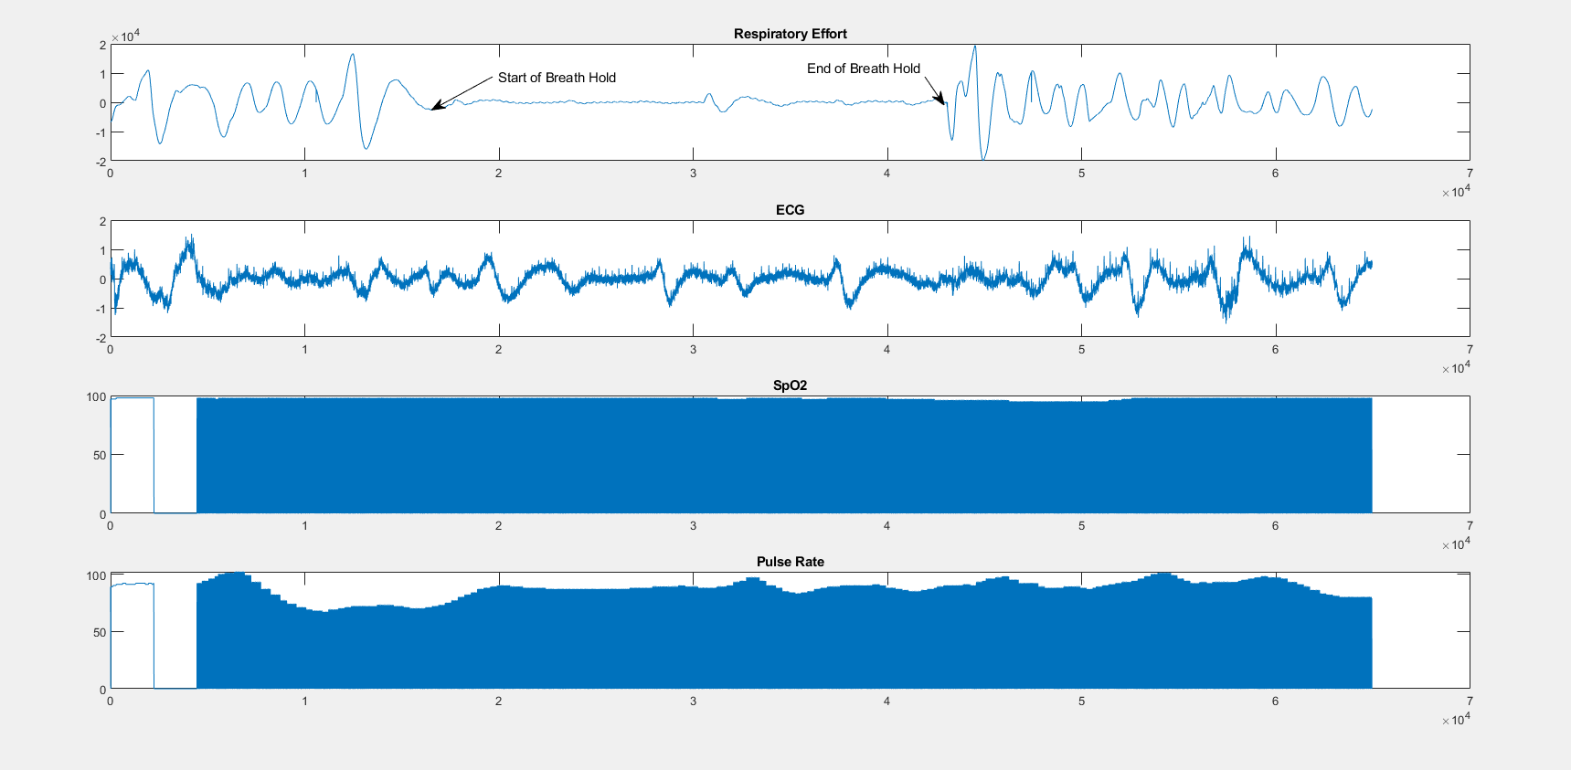

Figure 3. Inhaling and holding breath

**i) What is the pulse rate at the beginning and end of the breath hold? How long after resuming breathing did the value return to normal (if this happens during collection time period)?**

The pulse rate at the beginning of the breath hold was 71 and the pulse rate at the end of the breath hold was 89. The pulse rate did not return to the original value after the breath hold during the collection period.

**ii) What is the Sp02 at beginning and end of the breath hold? How long after resuming breathing did the value return to normal (if this happens during collection time period)?**

The Sp02 value at the beginning of the breath hold was 98 the Sp02 value at the end of the breath holding was 96. The duration of time that it took the Sp02 value to return to 98 after the breath hold ended was approximately 19 seconds

**iii) How long (in seconds) did it take for the Sp02 to decrease by 1%? 2%? 3%? (and so on till lowest value). How long to increase by 1%? 2%? Mark these time intervals on the Sp02 plot.**

From the start of the breath hold it took approximately 46 seconds to decrease by 1%, it took approximately 5 seconds to decrease from 1% to 2%, it took approximately 8 seconds to decrease from 2% to 3%. It took approximately 10 seconds to increase by 1%. It took approximately 1 second to increase from 1% to 2% and it took approximately 1 second to increase from 2% to 3%.

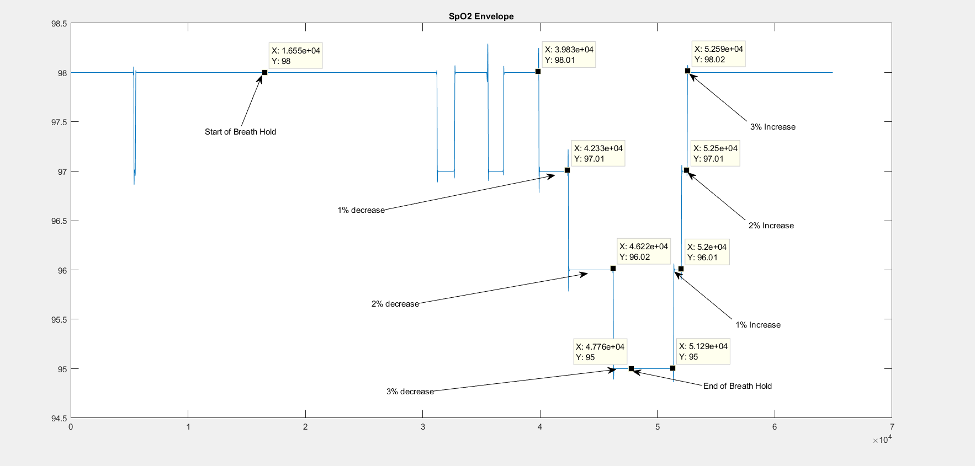

Figure 4. Sp02 envelope plot for inhale hold

**e) ‘Hold_Exhale’ files: Repeat question D (a-c) for ‘Hold_Exhale’ files.**

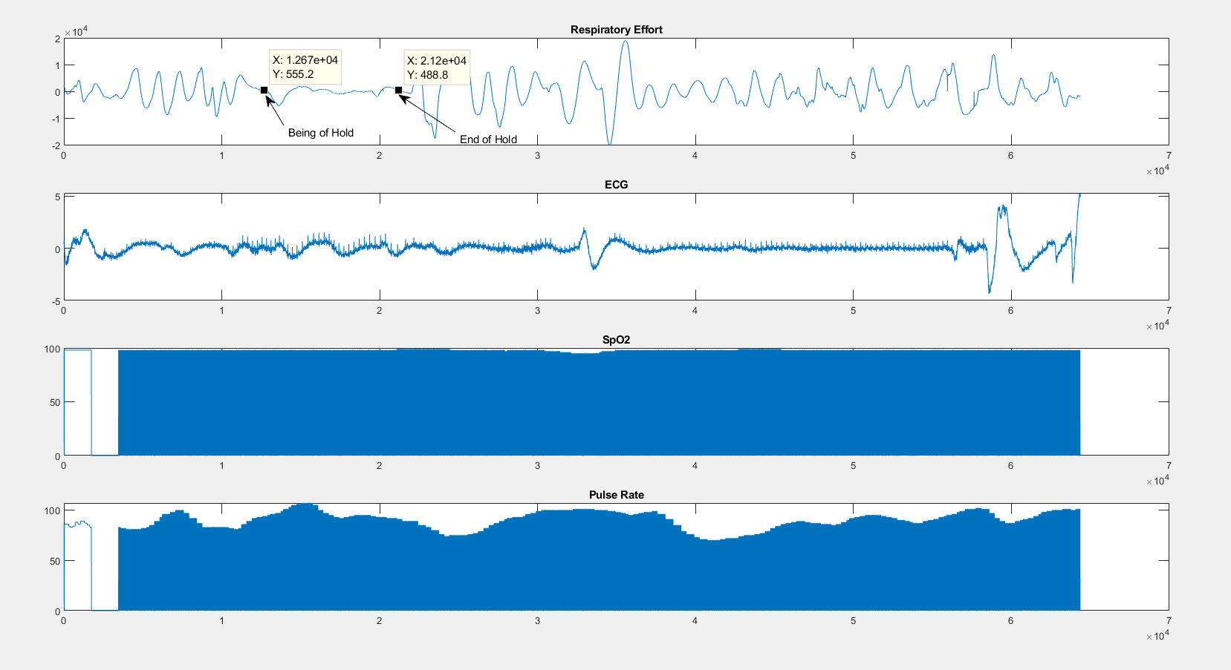

Figure 5. Exhaling and Holding Breath

**i) What is the pulse rate at the beginning and end of the breath hold? How long after resuming breathing did the value return to normal (if this happens during collection time period)?**

The pulse rate at the beginning of the breath hold was 94 and the pulse rate at the end of the breath hold was 91. The pulse rate did not return to the original value after the breath hold during the collection period.

**ii) What is the Sp02 at beginning and end of the breath hold? How long after resuming breathing did the value return to normal (if this happens during collection time period)?**

The Sp02 value at the beginning of the breath hold was 98 the Sp02 value at the end of the breath holding was 99. The duration of time that it took the Sp02 value to return to 98 after the breath hold ended was approximately 8 seconds

**iii) How long (in seconds) did it take for the Sp02 to decrease by 1%? 2%? 3%? (and so on till lowest value). How long to increase by 1%? 2%? Mark these time intervals on the Sp02 plot.**

It took 37.08s for Sp02 to decrease by 1%, 39.22s (2.14s) to decrease 2%, 40.40s (1.18s) to decrease 3%, 44.00s (3.60s) to increase 1%, 44.30s (0.3s) to increase 2%, and 46.02s (1.72s) to increase 3%.

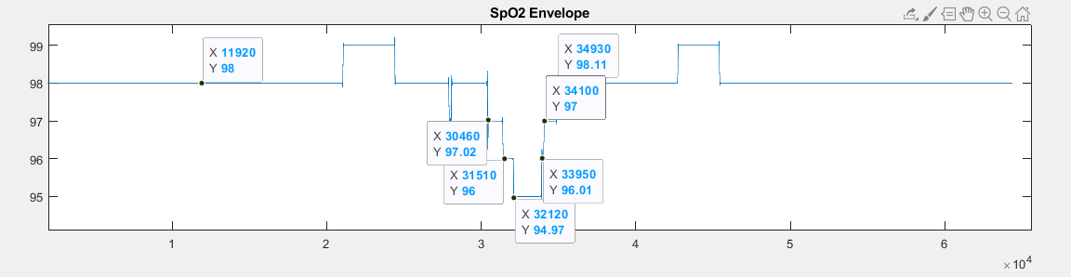

Figure 6: Marks points of % increases/decreases

**f) Explain the difference in your results for ‘Hold_Inhale’ and ‘Hold_Exhale’ (comparing subject 1’s inhale data to subject 1’s exhale data and repeat on subject 2 files…). (~200 words).**

Hold exhale decreased at a much faster rate, falling 1-2% in 2.14s as opposed to 5s with inhale. This makes sense because when you exhale you are removing all the air in your lungs so you have no oxygen to draw from, where as when you inhale and hold and you tissues are asking for more oxygen it can pull some from your freshly filled oxygen rich lungs. Both data samples increased at the same rate, about 1s per %. This is because in both cases, the subject begins breathing and the body begins sending out fresh oxygen to cells, the process' are the same.

**g)** **Using the information from the ‘Hold’ analysis:**

**i) Based on your findings is the pulse or the Sp02 signal the best respiratory arrest detector? Why does one signal have a quicker response time?**

Based on the findings in hold data, the best signal to best be used as a respiratory arrest detector would be pulse rate. The pulse rate began to show the effects of the respiratory arrest faster than the Sp02. The pulse rate began dropping after only 7.78s whereas the Sp02 show after 37.08s.

**ii) What causes the changes in Pulse rate?**

The pulse rate change is the body's way to conserve oxygen, everytime your heart beats blood enters the lungs and collects oxygen, so the faster your heart beats, the more oxygen it will use collect and send around the body. So the body slows down the heart rate to it can ration its supply of oxygen.

**h) ‘Rest’ files: Compare the heart rate value (in beats per minute) as determined by the pulse oximeter and by the ECG data (using 10 beats for the beginning, middle and end of your file). How similar/different are the values? Why is there (or not) a difference between the two measurement methods?**

There was a difference in the data between pulse oximeter measurement and ECG, this could be because of the pulse oximeter measures heart rate from blood flow data, which could be less accurate than the ECG measurement, which uses electrical signals from the heart, proving to be more accurate.

**Table 2. #2**

| **Method of determination** | **Beat per minute beginning** | **Beats per Minute middle** | **Beat per minute end** |
| --- | --- | --- | --- |
| **Pulse oximeter** | **91** | **93.27** | **94.55** |
| **ECG data** | **103.03** | **89.95** | **77.96** |

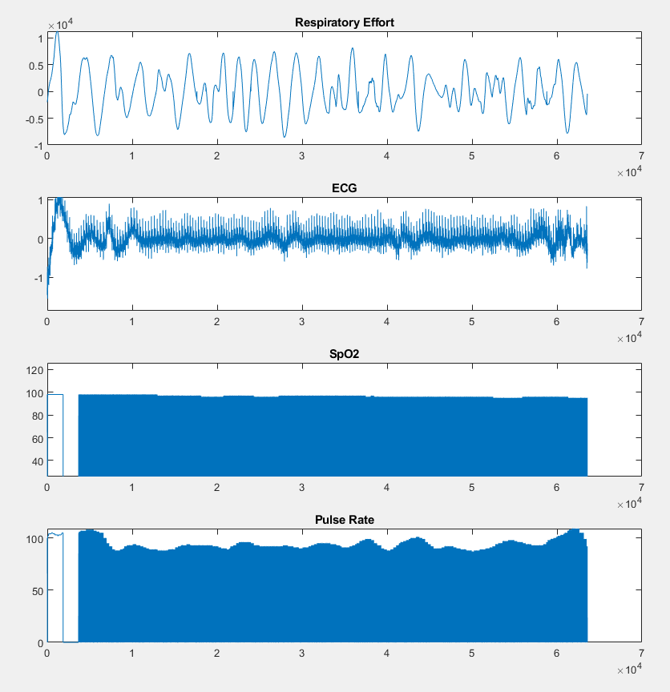

Figure 7. Rest

**i) ‘Running’ files: (max 400 words).**

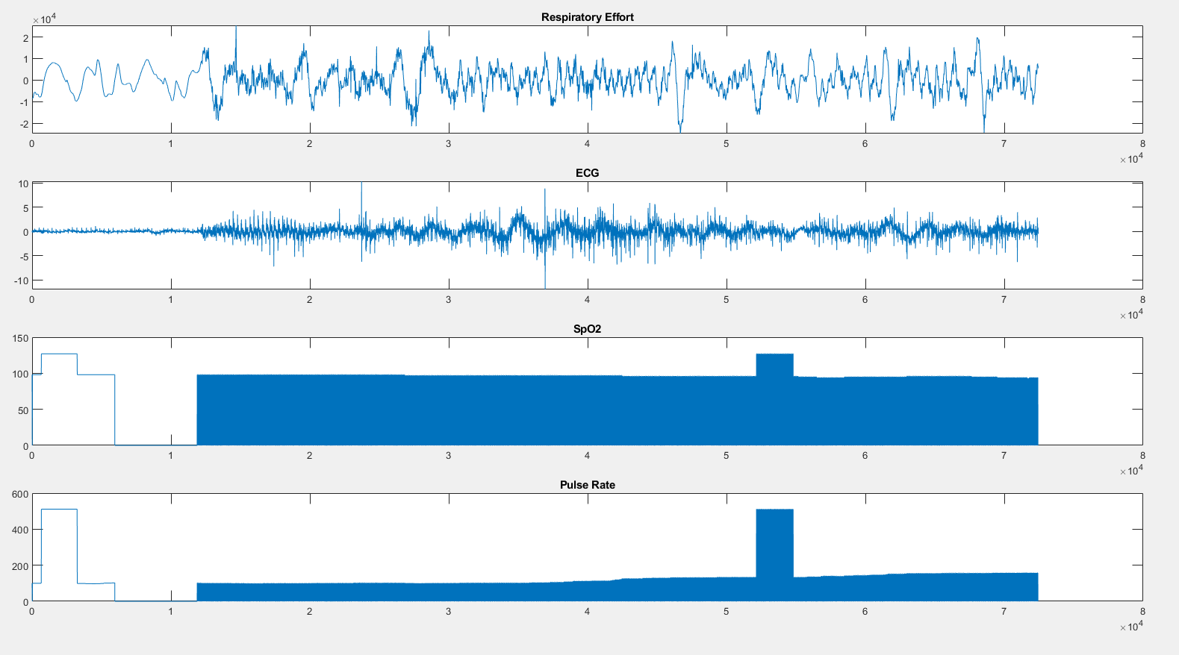

Figure 8. Running

**i) What changed in the respiratory effort signal? Why would this happen?**

The magnitude of the signal increased and breaths per minute also increased. This would happen because as you increase breathing rate, the effort changes. It takes more effort to breathe faster than the natural rhythm of breathing, so the amplitude increases both negative and positive peaks.

**ii) What changed in the Sp02 signal? Why would this happen?**

The Sp02 signal stayed constant at a value of 98, this is because the bodies tissues are still getting a constant supply of oxygen while breathing rate changes.

**iii) What changed in the Pulse rate signal? Why would this happen?**

The pulse rate increased with changes in breathing rate. This happens is to increase efficiency, the body ties its breathing and heart rate together, called the RSA (respiratory sinus arrhythmia), and the changes of heart rate with breathing is the bodies way of maintaining efficiency. So as breathing rate increases so will pulse rate, allowing the exchange of CO2 and O2 to be as efficient as possible.

**iv) What changed in the ECG signal? Why would this happen? Does running cause motion artefact in any of the signals? Why? If so, show a plot to support your answer.**

**The r to r intervals where short as there where a greater number of heart beats**

The ECG had a lot more noise than the other samples, this is due to the motion artifact caused by running. The subjects hands bouncing implements noise to the system, this noise causes the ECG plot to have a wandering baseline, meaning it does not consistently center about 0 on the y axis, it shifts up or down causing a zig zag pattern.

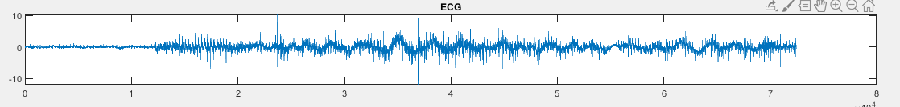Figure 9. ECG signal with wandering baseline

**j) ‘Running’ files: (max 100 words) How long did it take for the pulse rate and breathing rate signal to return to Reg. Br. or ‘at rest’ values?**

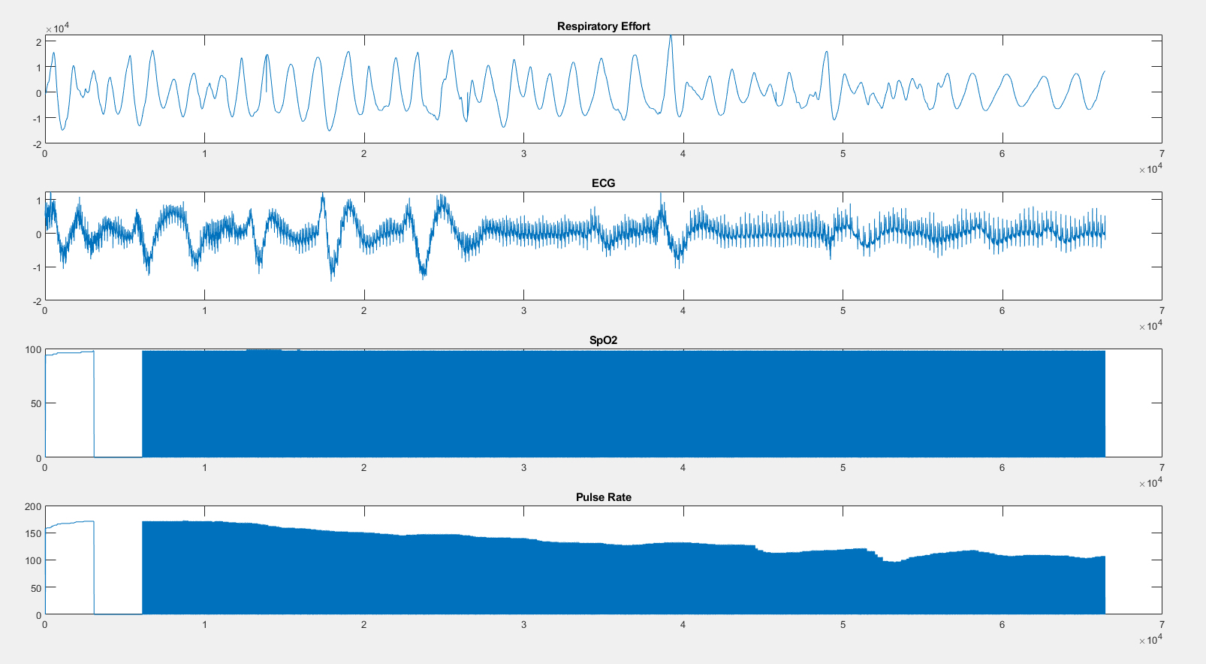

Figure 10. Recovery

**i) Was there any change in the Sp02 signal?**

The Sp02 signal stayed around a value of 98

**ii) How long did it take for the pulse rate and breathing rate signal to return to Reg. Br. or ‘at rest’ values?**

It took approximately 117 seconds after running had stopped for the breathing rate and pulse rate to return their respective rest values.

**iii) What happens in your body to account for the changes in the pulse rate and Sp02 signals? (~ 100 words).**

To account for a decrease in Sp02 the body will increase respiration rate and pulse rate to increase the Sp02 value. By increasing heart rate, the heart can circulate more blood, allowing more oxygen to be sent to the body thus increasing Sp02. To account for an increase in Sp02 the body will slow the pulse rate because it does not want to supply too much oxygen and change the pH of the blood. By adjusting pulse rate the body can remain in equilibrium.